2018 Negroamaro, Estate Bottled, Kelsey Bench – Lake County, Ca.

You may remember our last release of Negroamaro – plum and pepper, round, rustic-yet-friendly. In 2018 we took a different approach. Negroamaro is pretty aromatic in its youth, sort of gangly and all over the place in a fun way, and though the barrel aging of the prior release brought out some deeper elements, we felt like some fruit-forward charm was lost in translation. What would happen if it never went into a barrel at all, and we guarded every single aromatic molecule?

What happened was, sort of expected, but also not. That delicate pink-fig-flesh note still disappeared, but the fruit remained front and center, this time more red-toned with very bright and forward spice. This is a wine that likes air, and it will change every 15 minutes, with acid and tannin coming and going, fruit and texture moving and morphing.

The worst part is that our Negroamaro is a very shy producer, unlike in some other areas in Puglia. It is the one grape we grow that does not get any fruit thinning – no shaping bunches because they are already tiny, and there is no excess fruit to drop. We are lucky if we get close to three tons of crop per acre, our 400 vines only producing about 100 cases in a good year.

Label image: Johann Mylius was a composer, physician and ardent alchemist. His Philosophia Reformata from 1622 was a deep dive into scientific principles and doctoral Theology divided into seven parts, and seven of the 10 emblems on the cover link to the iconography of previous alchemists. The phrase “Vinum in Agris” means “wine of the countryside,” alluding to Negroamaro’s humble but satisfying nature.

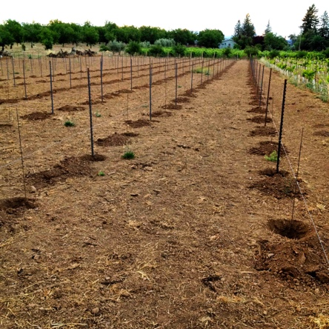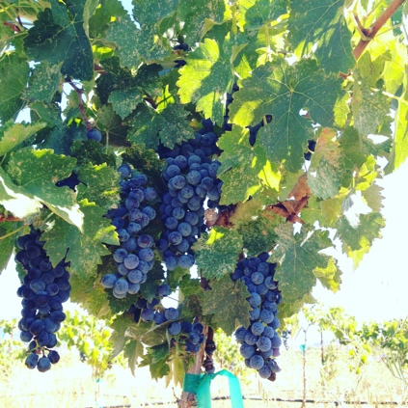

Prima Materia Vineyard & Winery ♦ 482 #B 49th Street, Oakland, Ca. 94609
www.prima-materia.com ♦ info@prima-materia.com

