Sagrantino – Estate Bottled
Kelsey Bench – Lake County, Ca.

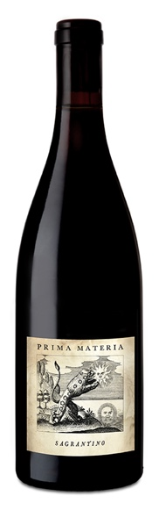
While Sagrantino can play the ancient grape card, having probably been mentioned by Pliny the Elder, it is also one of the wine world’s great new discoveries. Native to the isolated Montefalco area of Umbria, it enjoyed a long and storied history as a sweet wine dating back to 1598, but dry Sagrantino is a new invention going back to only 1980. Why? In short it has a wealth of tannin, and only more recently, gentle handling techniques have finally tamed them.

On the personal level, planting Prima Materia’s acre of Sagrantino in 2012 required an 800-mile road trip to Eastern Washington to pick up the vines, which were unavailable in California, and losing 35% of them under a foot of snow in 2013. In 2018 we lost 30% of the vintage in a bin-tipping catastrophe that flooded the barrel room. Something about the vine makes it a most troubled and demanding love, and after planting it in 2012, the first bottling is only being released now in the summer of 2019. A complicated relationship to be sure…

The wine: relatively tame by Sagrantino standards with only moderate tannin and firm red fruit. The young vines seem to have focused their energy on ripe fruit components with only a faint whiff of the dust, herbs and delicate flowers that future vintages promise. This bottling is comprised of a single barrel each from 2015, 2016, and 2017 vintages, which was the total production for each of those years with an average age of 22 months in neutral oak barrels. Unfined, and unfiltered as always. 72 cases total production, hand-bottled in August of 2018. Drinkable now (air will help soften tannins) but it will age gracefully, developing earth and herb tones with more bottle time. Retail Price $32, club reorder price $27.00

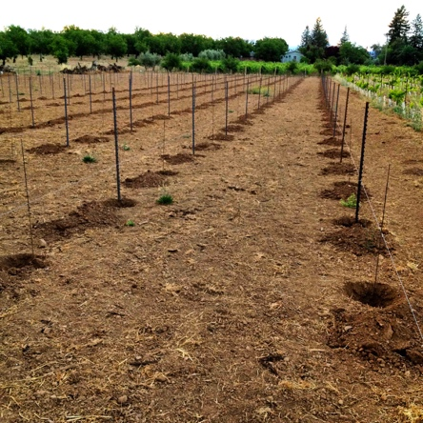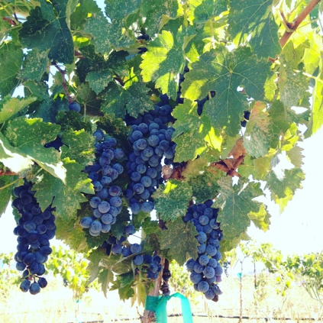

Prima Materia Vineyard & Winery ♦ 482 #B 49th Street, Oakland, Ca. 94609
www.prima-materia.com ♦ info@prima-materia.com

