Tocai Friulano, Graziano Vineyards, 2017
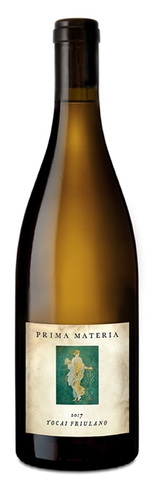
Potter Valley – Mendocino County, Ca.

This is the third vintage of Friulano we have made (2010 was from Fox Hill in Mendocino, and 2012 from Yolo County) but it is by far my favorite. Unfortunately, I was just told today by Greg Graziano that he will be ripping it out because it is too hard to sell and planting Vermentino, which is probably a good idea, but a wistful one as this bottling has great tension and complexity.

Somewhat like Carménère, Friulano has confusing history and was mistakenly called Sauvignon blanc (rather than vert) in Chile. It most likely originated in the Veneto in the 1500-1600’s and remained a local specialty for the most part in it’s adopted home of Friuli and Slovenia. To avoid confusion with Hungarian “Tokaji” the “Tocai” portion has been eliminated within the EU. The grape has struggled to grab the public’s interest, can hit high alcohol, and is not usually super crisp, which is so very of the moment.

The wine: bipolar. The curious thing about Friulano is that it can maintain good acidity with a heavy, full-bodied mouthfeel under the right conditions. Greg Graziano’s Potter Valley vineyard is a cold pocket, allowing enough time to ripen fully in October while holding great acid. Straw, floral bits and one customer swears curry leaf abound with a textural palate, and this is the unusual white wine that loves air, so let it breath… Unfined, unfiltered, aged 6 months in neutral barrels. 48 cases produced. Retail Price: $25, club repurchase price: $20.00

Label image: One of several Spring goddess/human/nymph frescos from somewhere between 89 BC and the destruction of Pompeii in 79 AD. Primavera di Stabiae is considered one of the greatest examples of the 3rd style, though the dreamy architectural surrealism we love so much is missing. The styles themselves are a fascinating aesthetic mirror, strongly paralleling today.

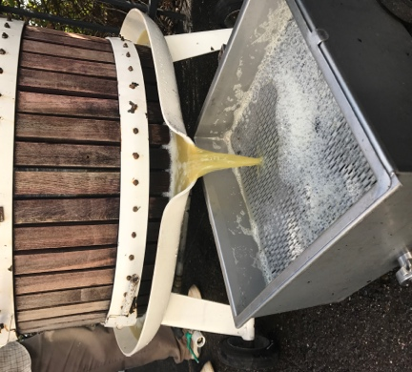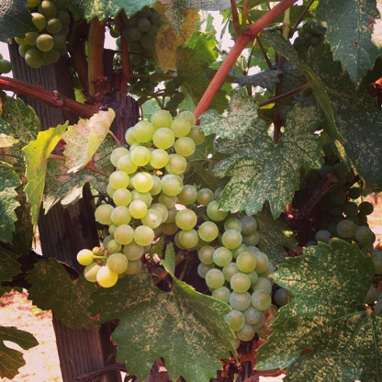

Prima Materia Vineyard & Winery ♦ 482 #B 49th Street, Oakland, Ca. 94609
www.prima-materia.com ♦ info@prima-materia.com

