Rosé • 2018
Estate Bottled
Kelsey Bench - Lake County

Grown at 1450’ elevation on red, obsidian-strewn volcanic soil resulting from Mt. Konocti’s violent upheaval in the Mayacamas runout, our 2018 rosé combines bright fruit and a savory palate in porch pounding machine.

Tasting notes: Darker and more fruit-driven than last year’s Provence-meets heavier grapes style, we have crystal-clear watermelon, strawberry, and peach on the nose. However, the crisp mouthfeel brings savory salinity, med/med+ acid, and big, salty fore- and mid-palate volume that almost seems born of calcareous soil and ancient dust. Pleasantly bipolar.

Vineyard: All Primitivo and Barbera planted in 2004, Negroamaro in 2011.

Winemaking: The Primitivo was harvested at 12% abv, direct pressed as a dedicated rosé. The Barbera was stainless saignee, as was the Negroamaro. Unfiltered, full malo, native yeast.

Vintage: Ah 2018. It started off fast and furious. We avoided the drenching rain of 2017 and as summer came it got hotter and hotter. 3 weeks of 100-degree days, and just as the vines started to look tired, then came a wall of fire. July was spent in smoke. Period. And then came magical cooling for months, day after day of perfect, slow-ripening 82-degree perfection. While what became a great season was marred by the specter of smoke, our grapes tested clean and rosé is a way to double down on smoke-free winemaking. Higher acidity, less fruit, Old-World inflected angularity is the Lake County flavor of 2018.

Label Image: From The Journey of the Fortunate Prince in 1610 we see full alchemical drama in play. The eagle is Mercury, linking heaven and earth while the lion (Sulphur) with severed paws is the living axiom to dissolve the fixed and coagulate the volatile. Burning trees, ouroboric dragons, old men eating the moon, a metallic tree stump being revivified by the fountain of youth, an eternal hourglass demanding focused patience while all things are encased in the myrtle tree of love. All these things are connected by a strong branch growing from metals below to life above. Clearly French alchemy in fine form.

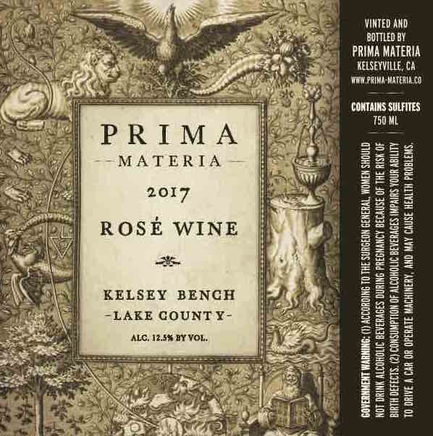

50% Primitivo direct press
30% Barbera saignee
15% Sangiovese direct press
5% Negroamaro saignee

2 neutral barrels used for Primitivo aging with battonage
stainless for the rest

racked once, no filtering
combined for two months
then bottled by hand on
5/01/2018

pH 3.34
TA 6.9gm/l
13.2% abv

125 cases produced

